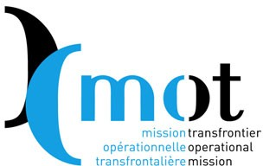
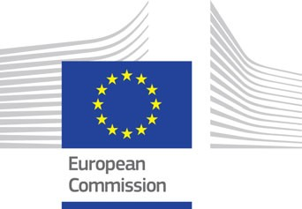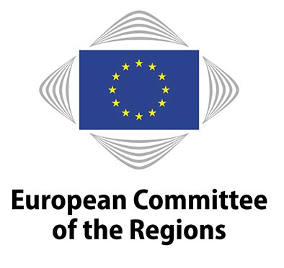Press release

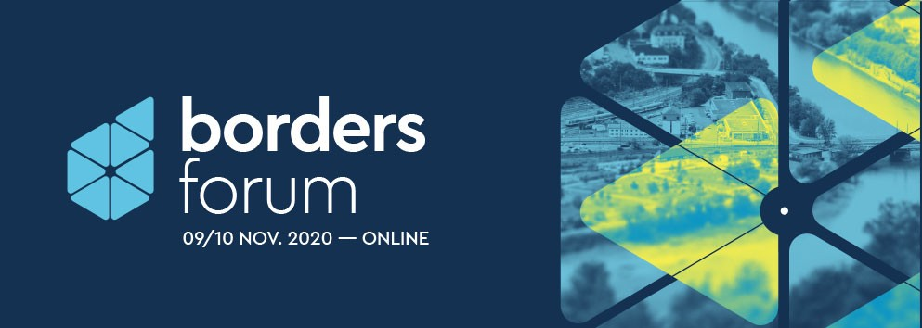

The 1st BORDERS FORUM will be held on the 9 and 10 November online

Cross-border territories on the frontline of the Covid-19
Under the high patronage of the President of the French Republic Emmanuel Macron, the
1st Borders Forum, organised by the Mission Opérationnelle Transfrontalière (MOT), in partnership with the European Commission and the European Committee of the Regions, will be held on 9 and 10 November 2020 entirely online.
It will be inaugurated by Elisa Ferreira, European Commissioner for Cohesion and Reforms, Apostolos Tzitzikostas, President of the European Committee of the Regions, and Christian Dupessey, President of the MOT, Mayor of Annemasse and President of the Metropolitan Pole of the French Genevois. The event will host a number of high-level political leaders: Ministers, Members of Parliament, Presidents of local authorities, etc., all stakeholders of cross-border territories in Europe.
ITS PURPOSE

To put in the spotlight territories that have been severely affected by the health crisis and the closing of borders, with the aim of highlighting the "emergency" of a better response to their problems and of a stronger cohesion between the actors involved. Put to the test in recent months, these territories represent no less than 40% of European territory, with 2 million cross-border workers (400,000 on the French borders).

To present a "European Cross-border Citizens' Alliance“* at the European level, with the support of the European Committee of the Regions, to put cross-border territories at the centre of national and European political concerns.

*Launched by the MOT, the AEBR (Association of European Border Regions) and the CESCI (Central European Service for Cross-Border Initiatives, Hungary)

Press release

The first day will be devoted to cross-border territories in Europe and to the 10th EGTC Platform of the European Committee of the Regions. It will address the internal borders of Europe and the European management of the Covid crisis, and its external borders on the eve of the Brexit and in the wake of the American elections. With interventions from Clément Beaune, French Minister of State for European Affairs, Judit Varga, Hungarian Minister of Justice, Claude Turmes, Luxembourg Minister for Energy and Spatial Planning, Jean Rottner, President of the Grand Est Region, Vincenzo Amendola, Italian Minister for European Affairs, Konrad Szymanski, Polish Minister for European Affairs, Heike Raab, Secretary of State for Europe, Media and Digital of the German Land of Rhineland-Palatinate.

The second day, inaugurated by Jean Jouzel, climatologist and glaciologist, Member of the French Academy of Science, will focus on cross-border territories at the French borders. It will reveal their diversity and demonstrate their specific features, from Dunkirk to Bayonne, not forgetting Nice, Geneva and Strasbourg, and will discuss decentralisation, deconcentration and, above all, differentiation. The conference will feature speeches by Pia Imbs, President of the Strasbourg Eurometropolis, Christian Estrosi, President of the Nice Côte d'Azur Metropolis, Annie Genevard,
Vice-President of the National Assembly, Member of Parliament for the Doubs, Roland Theis, Secretary of State to the Minister of Justice of the Saarland (Germany) and Commissioner for European Affairs, Carlos Moreno, researcher and scientific director, and Thierry Mallet, CEO of Transdev.

The Borders Forum will be closed by Jacqueline Gourault, French Minister for Territorial Cohesion and Relations with Local and Regional Authorities, and Christian Dupessey, President of the MOT, Mayor of Annemasse, President of the Metropolitan Pole of the French Genevois.

A press conference will be held online on 9 November at 11h15.
If you wish to participate, please register: Domitille Ayral, domitille.ayral@mot.asso.fr
To download:
- The press kit: http://www.espaces-transfrontaliers.org/fileadmin/user_upload/documents/Borders-forum-PRESS-KIT-EN.pdf
- More info, programme, etc: https://bordersforum.eu/language/en/elementor-2382/

WHAT IS THE MISSION OPÉRATIONNELLE TRANSFRONTALIERE (MOT)?

The MOT is an association specialised in supporting cross-border cooperation. It was established in 1997 on the initiative of the French government. Its network brings together more than 70 cross-border cooperation actors: cross-border structures, regions, departments, municipalities, groupings of municipalities and communities, states, businesses, federations and networks, urban planning agencies, etc. Its mission is to defend the interests of cross-border territories, to establish networks between them and to provide them with operational and legal assistance. Its multi-level positioning promotes dialogue between national and European authorities and local and regional actors, to ensure that cross-border issues are better taken into account in legislation.

More info: http://www.espaces-transfrontaliers.org/en

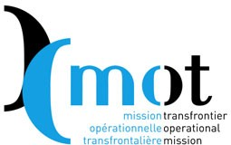
Mission opérationnelle transfrontalière
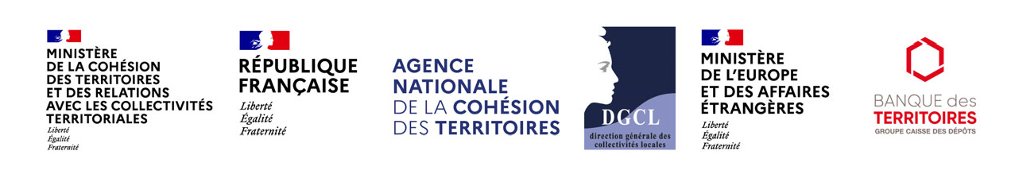
38 rue des Bourdonnais - 75001 Paris - France
Tél. : +33 (0)1 55 80 56 80 – www.espaces-transfrontaliers.eu

